





Hash Your First Block – Blockchain Basics and Setup.

Objective/Aim:
To understand the basic structure of a blockchain and demonstrate the concept of block hashing and setting up the egeth.

Apparatus/Software Used:
- Laptop/PC
- Word for documentation
- Egeth

Theory/Concept:
Blockchain is a type of digital ledger technology that is shared, secure, and immutable. It is used to record transactions and track digital or physical assets in a distributed network.
Instead of storing data in a central server, blockchain stores data across a network of computers (nodes). This decentralized nature ensures that no single entity controls the data, making it highly secure and transparent.
Once data is recorded in a block, it is linked to the previous block using cryptographic hashes, forming a chain of blocks — hence the name "blockchain".
This structure makes it almost impossible to alter the data without detection. If someone wants to change any information, they would need the approval of at least 51% of the nodes in the network, which is extremely difficult to achieve.

Procedure:

1: to hash a single block https://andersbrownworth.com/blockchain/block
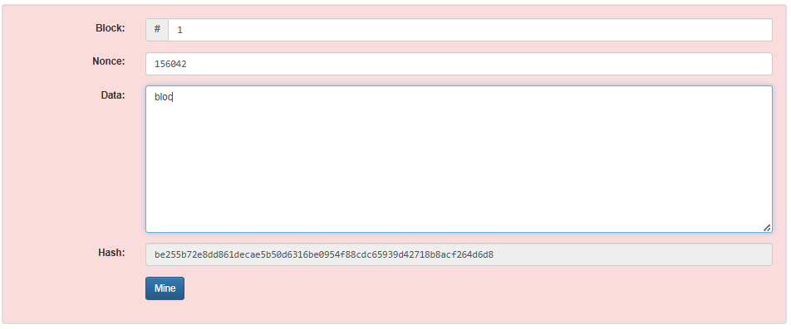
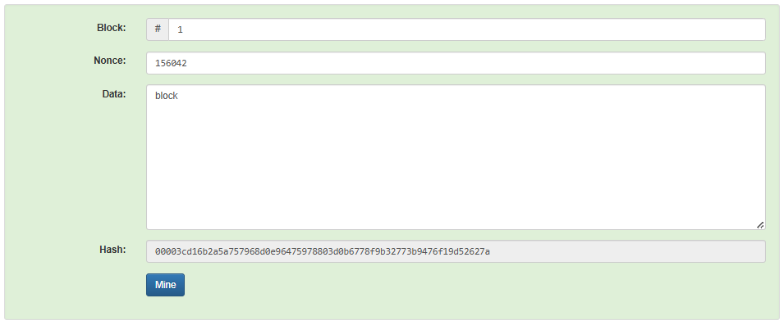
2: Enter the data and you will notice that with the data the hash also changes and then mine it
.

Observation Table:
Previous hash | After adding data
be255b72e8dd861decae5b50d6316be0954f88cdc65939d42718b8acf264d6d8 | 00003cd16b2a5a757968d0e96475978803d0b6778f9b32773b9476f19d52627a

